# PMI TES QA activity: Quick Guide (April 2019)

## SECTION A. Purpose of TES QA visits

PMI TES QA visits and checklists are intended to 1) verify that the main steps in TES data collection are taking place, are documented, and are accurate and 2) identify areas for improvement and communicate corrective steps with TES staff. Visits, which typically take half of a day, should begin with an in-brief with the clinical coordinator and end with a joint debrief of all clinical and lab staff to review the checklist results and next steps for corrective actions. Following the visit, a summary of the visit should be sent to the PI and headquarters team (Leah M, Eric H, Meera V).

## SECTION B. Background and methodology for TES

Therapeutic Efficacy Studies (TES) are conducted according to the 2009 WHO Methods for surveillance of antimalarial drug efficacy1 to give basic data on the efficacy of currently recommended first and second-line medicines and possibly replacement medicines. TES sentinel surveillance over time provides data on the continuing efficacy of treatments or an indication of the development of drug resistance.

Briefly, the study is a prospective clinical trial with one or more treatment arms and 28 or 42 days of follow up after enrollment and initiation of the treatment. Standard inclusion and exclusion criteria are given below, along with the participant follow-up schedule (attached) and criteria for final classification of participants. In addition to clinical assessments at enrollment and follow up, blood samples are collected for microscopy and genotyping. At the end of follow up, participants are classified according to whether parasitemia with or without symptoms persisted or recurred during the follow up period (treatment failure) or whether the response to treatment was adequate. An additional step of genotyping recurrent parasitemias provides information on whether they are a return of the original infection, indicating possible drug resistance, or a new infection acquired during the follow up period after the original infection was effectively treated.

**Standard WHO inclusion criteria** (please consult study protocol for specific criteria)

* age will vary; often 6 – 59 months or 6 months – 10 years
* mono-infection with *P. falciparum* detected by microscopy (minimum and maximum parasitemia will vary; often 1,000 – 100,000 p/ul)
* presence of axillary or tympanic temperature ≥ 37.5 °C or oral or rectal temperature of ≥ 38 °C or history of fever during the past 24 h
* ability to swallow oral medication
* ability and willingness to comply with the study protocol for the duration of the study and to comply with the study visit schedule
* informed consent from the patient or from a parent or guardian in the case of children

**Standard WHO exclusion criteria** (please consult study protocol for specific criteria)

* presence of general danger signs in children aged under 5 years or signs of severe falciparum malaria (see definitions in protocol/WHO guidelines Appendix 1)
* mixed or mono-infection with another *Plasmodium* species detected by microscopy
* presence of severe malnutrition (defined as a child whose growth standard is below –3 z-score, has symmetrical oedema involving at least the feet or has a mid-upper arm circumference < 110 mm)

1 WHO 2009. Methods for surveillance of antimalarial drug efficacy. <http://www.who.int/malaria/publications/atoz/9789241597531/en/>

* presence of febrile conditions due to diseases other than malaria (e.g. measles, acute lower respiratory tract infection, severe diarrhoea with dehydration) or other known underlying chronic or severe diseases (e.g. cardiac, renal and hepatic diseases, HIV/AIDS)
* regular medication, which may interfere with antimalarial pharmacokinetics
* history of hypersensitivity reactions or contraindications to any of the medicine(s) being tested or used as alternative treatment(s)
* a positive pregnancy test or breastfeeding (include this criterion only if adults are included)
* unable to or unwilling to take contraceptives (for women of child-bearing age)

# Follow-up schedule

See below (from citation1). (X) indicates that these time points are optional, including follow up at days 35 and 42 which is required for DHA-piperaquine but optional for other medicines.

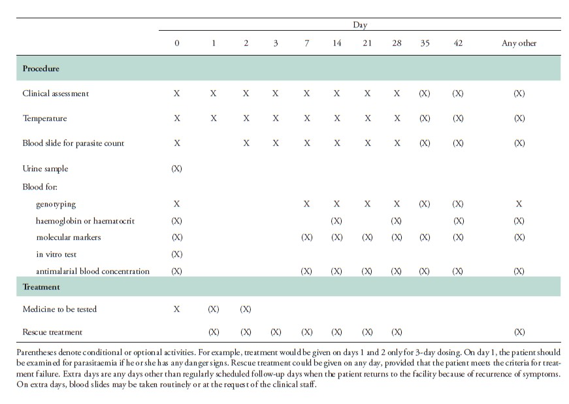

# Final classification criteria

Early Treatment Failure if any of the following criteria are met:

* danger signs or severe malaria on day 1, 2 or 3 in the presence of parasitaemia
* parasitaemia on day 2 higher than on day 0, irrespective of axillary temperature
* parasitaemia on day 3 with axillary temperature ≥ 37.5 ºC
* parasitaemia on day 3 ≥ 25% of count on day 0

Late Treatment Failure if any of the following criteria are met:

*Late Clinical Failure*

* danger signs or severe malaria in the presence of parasitaemia on any day between day 4 and day 28 (or day 42) in patients who did not previously meet any of the criteria of early treatment failure
* presence of parasitaemia on any day between day 4 and day 28 (or day 42) with axillary temperature ≥ 37.5ºC (or history of fever depending on inclusion criteria) in patients who did not previously meet any of the criteria of early treatment failure

*Late Parasitological Failure*

* presence of parasitaemia on any day between day 7 and day 28 (or day 42) and axillary temperature <
  + 37.5 ºC in patients who did not previously meet any of the criteria of early treatment failure or late clinical failure

Adequate Clinical and Parasitological Response:

* absence of parasitaemia on day 28 (or day 42), irrespective of axillary temperature, in patients who did not previously meet any of the criteria of treatment failure listed above

***SECTION C. Checklist reference guide: explanation of questions, user notes, and discussion points Site checklist*** *-* one checklist form per TES site visited.

# All folders containing completed study forms are stored in a secure area (locked drawer, cabinet or room), and completed study forms are organized by patient ID.

* Rationale: Ensure that data are stored securely and cannot be tampered with, lost, or damaged; to ensure that patient records can be located easily by study staff and visitors not involved in the study.
* Common pitfalls and recommendations: Forms are stored in one place but a lock is not available, forms are not organized by patient ID (organization by enrollment date is also acceptable). Recommend that site coordinator request lock(s) to secure data forms and organize forms for easy retrieval.

# Screening logbook is up-to-date (at least through the previous day). Also applies to 3) for recording participant reimbursement and 4) for documentation of laboratory results by laboratory staff.

* Rationale: Participant enrollment data should be entered in the logbook in real time to avoid gaps, missing patient information, and errors in recording that cannot be tracked down after the fact.
* Common pitfalls and recommendations: Enrollment forms are completed but participant data are not entered in the screening log. Recommend that clinical staff enforce the entry of enrollment information in logbook as each participant is screened.
* **Participant reimbursement log is up-to-date (at least through the previous day)**
* **Laboratory logbook is up-to-date (at least through the previous day)**

# Two slide reads are performed for every slide and a third read is performed when the first two are discordant.

* Notes: Ask the laboratory staff about who reads slides and what is done in the case of discordant results. May also ask whether any other microscopy QA is in place (sending a subset of slides to another site for cross-checking, participation in a proficiency testing program…)
* **If the protocol includes HRP2 testing: Patients are enrolled in the study based on results of microscopy, not RDT**
* Notes: Otherwise all samples that potentially have an hrp2 gene deletion would be screened out.

# Appropriate slide preparation and reading standard operating procedures are available and accessible.

* Notes: Request to see SOPs if not readily visible.

***Participant checklist*** – one checklist form per study participant record reviewed (10 total per site).

# (A) Study Forms

1. **All study forms are present in the participant’s folder.** *See protocol for specified required forms including consent/assent forms, screening forms, Day 0 enrollment, days of follow-up, and final classification form.*

* Note: ALL enrolled participants should have consent/assent, screening, and Day 0 enrollment forms. Follow-up forms should be available to most recently scheduled day if follow-up is ongoing. Only participants that have competed follow-up will have a final classification form.

# The screening form indicates that the participant meets all study entry criteria according to the study protocol for inclusion and exclusion.

* Rationale: Ensure that inclusion and exclusion criteria have been applied and are recorded.
* Notes: Inclusion/exclusion criteria are also listed in Section B above.

# Consent/Assent forms are completed (including date and signature of staff and study participants) and second copy has been provided to the participant or guardian (not attached to first copy and confirm with clinical staff that copies are provided).

* Notes: Look for evidence that second copy has been torn off. Confirm verbally with study staff that second copy is provided to participant or guardian.

1. **Enrollment form and follow-up day forms are completed.** *Note that microscopy is not conducted on Day 1 and an antimalarial is given on Days 0-2.*

# The participant’s unique identification number is on all study forms.

1. **Follow-up dates in study forms are correct and correspond to standard follow-up days (see protocol for follow-up schedule)**
   * Notes: Standard follow-up schedule is provided earlier in this document.
2. **Dosage of medication, including weight and use of second dose in case of vomiting after taking medication, is documented and correct (*Day 0, Day 1, Day 2*).** *Consult dosing chart and verify which drug presentations are used to determine if # of pills is correct.*

* Notes: Request dosing chart if not available in study protocol. If an AL arm is included, ask about measures taken to ensure that AL is given with food and whether the second AL dose is observed by the provider each day.

**8a) Parasitemia levels are recorded on enrollment and follow-up day forms (*Day 0, Day 2, Day 3, Day 7, Day 14, Day 21, Day 28 [Day 35 and 42 if applicable]* or until most recent scheduled day if follow-up is ongoing*)*. 8b) Patients are withdrawn from the study if Day 2 parasitemia levels are greater than Day 0 or if Day 3 parasitemia levels are greater than 25% of Day 0 according to WHO Guidelines.**

* Rationale: Increasing parasitemia after the initiation of treatment indicates early treatment failure and requires a switch to rescue therapy as described in the study protocol.

1. **The decision to continue follow-up or to complete the Final Classification Form is correct (*Day 1, Day 2, Day 3, Day 7, Day 14, Day 21, Day 28 [Day 35 and 42 if applicable]* or until most recent scheduled day if follow-up is ongoing).** *See WHO Guidelines, protocol, or reference sheet for final classification criteria.*

* Notes: Final classification criteria are available in Section B of this guide.

1. **Laboratory**

Filter papers

# The participant’s unique identification number, date, and day are clearly labeled on all filter papers.

* 1. **Filter papers were collected for the participant on Day 0, Day 7, Day 14, Day 21,and Day 28 [Day 35 and 42 if applicable] or until most recent scheduled day if follow-up is ongoing.**
  2. **Blood is captured in the center of the printed circles in the filter papers, reaching as much saturation within the circle as possible.**

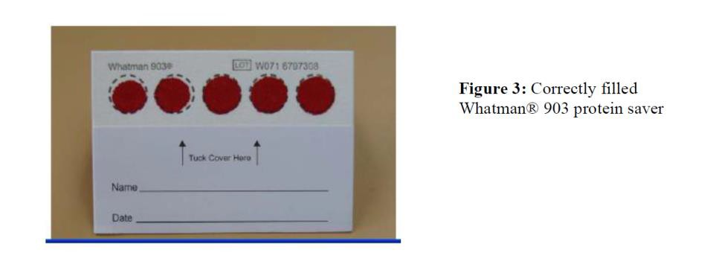

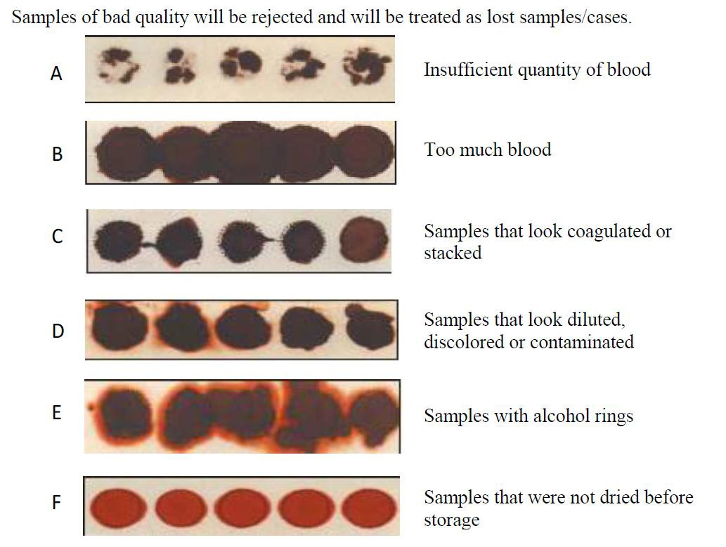

* 1. **Filter papers are dated, stored in individual plastic bags (one filter paper/bag) with desiccant, and organized by day of visit or by patient.**
  + Notes: Multiple filter papers can be stored per bag if wrapped individually (i.e., in foil)

# Date written on individual filter papers matches date in corresponding clinical forms.

* Notes: During debrief, discuss the plan for genotyping day 0 and day of recurrence filter paper samples. Where and when will the testing be conducted and is there a plan in place for sample transfer, analysis, and sharing of results?

Blood slides

# The participant’s unique identification number, date and follow up day are labeled on all smear slides.

1. **Slides were prepared and labeled with day for the participant on Day 0, Day 2, Day 3, Day 7, Day 14, Day 21, and Day 28 [Day 35 and 42 where applicable] or until most recent scheduled day if follow-up is ongoing.**
2. **All blood slides have two thick (fast and slow stain) and, when appropriate, one thin blood smear as per WHO Guidelines.** *Note that the thin smear is often omitted because it is mainly relevant for sites with >1 Plasmodium species.*